Spring

What is IOC or inversion of control?
Inversion of the control means now we have transfer the control of creating the object from our own using new operator to container or framework. Now it’s the responsibility of container to create an object as required.

Explain the Spring Bean-LifeCycle?
- The container will look the bean definition inside configuration file (e.g. bean.xml).
- using reflection container will create the object and if any property is defined inside the bean definition then it will also be set.
- If the bean implements the BeanNameAware interface, the factory calls setBeanName() passing the bean’s ID.
- If the bean implements the BeanFactoryAware interface, the factory calls setBeanFactory(), passing an instance of itself.
- If there are any BeanPostProcessors associated with the bean, their post- ProcessBeforeInitialization() methods will be called before the properties for the Bean are set.
- If an init() method is specified for the bean, it will be called.
- If the Bean class implements the DisposableBean interface, then the method destroy() will be called when the Application no longer needs the bean reference.
- If the Bean definition in the Configuration file contains a 'destroy-method' attribute, then the

What are the difference between BeanFactory and ApplicationContext
ApplicationContext. | BeanFactory
Here we can have more than one config files possible | In this only one config file or .xml file
Application contexts can publish events to beans that are registered as listeners | Don't support.
Support internationalization (I18N) messages | It’s not
Support application life-cycle events, and validation. | Doesn’t support.
Supports many enterprise services such JNDI access, EJB integration, remoting | Doesn’t support.

Spring MVC
What is default scope of bean in Spring framework & Soring WebApplication? (answer)
The default scope of a Spring bean is the Singleton scope and in the web application default scope of a spring bean is request scope. Singleton bean means the same instance of a bean is shared with all other beans, while request scope means a bean is alive only for a request.
What is the difference between @Controller and @RestController?
@RestController is better when you are developing RESTful web services using Spring MVC framework. It's a combination of @Controller + @ResponseBody annotation which allows the controller to directly write the response and bypassing the view resolution process, which is not required for RESTful web service.
It also instructs DispatcherServlet to use different HttpMessageConverters to represent the response in the format client is expecting e.g. HttpMessageJackson2Convert to represent response in JSON format and JAXB based message converts to generate XML response

What does @RequestMapping annotation do? (answer)
The @RequestMapping annotation is used to map web requests to Spring Controller methods. You can map request based upon HTTP methods e.g. GET and POST and various other parameters. For examples, if you are developing RESTful Web Service using Spring then you can use produces and consumes property along with media type annotation to indicate that this method is only used to produce or consumers JSON as shown below:
@RequestMapping (method = RequestMethod.POST, consumes="application/json")
public Book save(@RequestBody Book aBook) {
return bookRepository.save(aBook);
}

When do you need @ResponseBody annotation in Spring MVC?
The @ResponseBody annotation can be put on a method to indicates that the return type should be written directly to the HTTP response body (and not placed in a Model, or interpreted as a view name).
@RequestMapping(path = "/hello", method = RequestMethod.PUT)
@ResponseBody
public String helloWorld() {
return "Hello World";
}
Alternatively, you can also use @RestController annotation instead of @Controller annotation. This will remove the need for using @ResponseBody because as discussed in the previous answer, it comes automatically with @RestController annotation.

What does @PathVariable do in Spring MVC? Why it's useful in REST with Spring?
For example, in the URL http://myapp.com/books/101 if you want to extract 101 the id, then you can use @PathVariable annotation of Spring MVC
Where do you need @EnableWebMVC? (answer)
The @EnableWebMvc annotation is required to enable Spring MVC when Java configuration is used to configure Spring MVC instead of XML. It is equivalent to <mvc: annotation-driven> in XML configuration.

How to Call Stored procedure in Spring Framework?
To call a Stored procedure in Spring framework you need to create Class which will should extends StoredProcedure class. You just need to call the execute method from the DAO layer.
public class EmployeeInfo extends StoredProcedure
{
private static final String EMP_ID = "EMP_ID";
private static final String EMP_NAME = "EMP_NAME";
private static final String JOIN_DATE = "JOIN_DATE";
public SnapshotSearchStoredProcedure(DataSource dataSource, String procedureName)
{
super(dataSource, procedureName);
declareParameter(new SqlParameter(EMP_ID, Types.NUMERIC));
declareParameter(new SqlOutParameter(EMP_NAME, Types.VARCHAR));
declareParameter(new SqlOutParameter(JOIN_DATE, Types.VARCHAR));
compile ();
}
public Map execute(Integer empId)
{
Map<String, Object> inputs = new HashMap<String, Object>();
inputs.put(P_CLD_IDR, empId);
Map<String, Object> result = execute (inputs);
return result;
}
}

Spring Security
If we think about the meaning of authentication, it seems that it is all about a client identifying itself to the server. After client identification is done, the server can remember the client each time the request comes from the client. There are two common approaches to authentication mechanisms: one of them is called "Session Cookie Based" and the other one is "Token Based".

Session Cookie based
The most common approach we probably all know is to use a server generated secret token (Session key) in the form of a JSESSIONID cookie. Initial setup for this is near nothing these days perhaps making you forget you have a choice to make here in the first place. Even without further using this “Session key” to store any other state “in the session”, the key itself is in fact state as well. I.e. without a shared and persistent storage of these keys, no successful authentication will survive a server reboot or requests being load balanced to another server.

OAuth2 / API keys
Whenever talking about REST APIs and Security; OAuth2 and other types of API keys are mentioned. Basically they involve sending custom tokens/keys within the HTTP Authorization header. When used properly both relieve clients from dealing with Cookies using the header instead. This solves CSRF vulnerabilities and other Cookie related issues. One thing they do not solve however is the need for the server to check the presented authentication keys, pretty much demanding some persistent and maintainable shared storage for linking the keys to users/authorizations.
private HttpHeaders createHeaders(final String userId, final String password) {
String auth = userId + ":" + password;
byte[] encodedAuth = Base64.encodeBase64(auth.getBytes(StandardCharsets.US_ASCII));
String authHeader = "Basic " + new String(encodedAuth);

HttpHeaders headers = new HttpHeaders();
headers.set("Authorization", authHeader);
return headers;
}

private ResponseEntity<String> makeRestCall(String url, String userId,
String password) {
// Basic Auth only.
if (!"".equals(userId) && !"".equals(password)) {
return restOperations.exchange(url, HttpMethod.GET,
new HttpEntity<>(createHeaders(userId, password)),
String.class);

} else {
return restOperations.exchange(url, HttpMethod.GET, null,
String.class);
}

}

General Questions – Spring Interview Questions

1. What are the major features in different versions of Spring Framework?

Features of Spring Framework
Version | Logo | Feature
Spring 2.5 |  | This version was released in 2007. It was the first version which supported annotations.
Spring 3.0 |  | This version was released in 2009. It made full-fledged use of improvements in Java5 and also provided support to JEE6.
Spring 4.0 |  | This version was released in 2013. This was the first version to provide full support to Java 8.

2. What is a Spring Framework?
- Spring is a powerful open source, application framework created to reduce the complexity of enterprise application development.
- It is light-weighted and loosely coupled.
- It has layered architecture, which allows you to select the components to use, while also providing a cohesive framework for J2EE application development.
- Spring framework is also called the framework of frameworks as it provides support to various other frameworks such as Struts, Hibernate, Tapestry, EJB, JSF etc.

3. List the advantages of Spring Framework.
- Because of Spring Frameworks layered architecture, you can use what you need and leave which you don’t.
- Spring Framework enables POJO (Plain Old Java Object) Programming which in turn enables continuous integration and testability.
- JDBC is simplified due to Dependency Injection and Inversion of Control.
- It is open-source and has no vendor lock-in.

4. What are the different features of Spring Framework?
Following are some of the major features of Spring Framework :
- Lightweight: Spring is lightweight when it comes to size and transparency.
- Inversion of control (IOC): The objects give their dependencies instead of creating or looking for dependent objects. This is called Inversion Of Control.
- Aspect oriented Programming (AOP): Aspect oriented programming in Spring supports cohesive development by separating application business logic from system services.
- Container: Spring Framework creates and manages the life cycle and configuration of the application objects.
- MVC Framework: Spring Framework’s MVC web application framework is highly configurable. Other frameworks can also be used easily instead of Spring MVC Framework.
- Transaction Management: Generic abstraction layer for transaction management is provided by the Spring Framework. Spring’s transaction support can be also used in container less environments.
- JDBC Exception Handling: The JDBC abstraction layer of the Spring offers an exception hierarchy, which simplifies the error handling strategy.

5. How many modules are there in Spring Framework and what are they?
There are around 20 modules which are generalized into Core Container, Data Access/Integration, Web, AOP (Aspect Oriented Programming), Instrumentation and Test.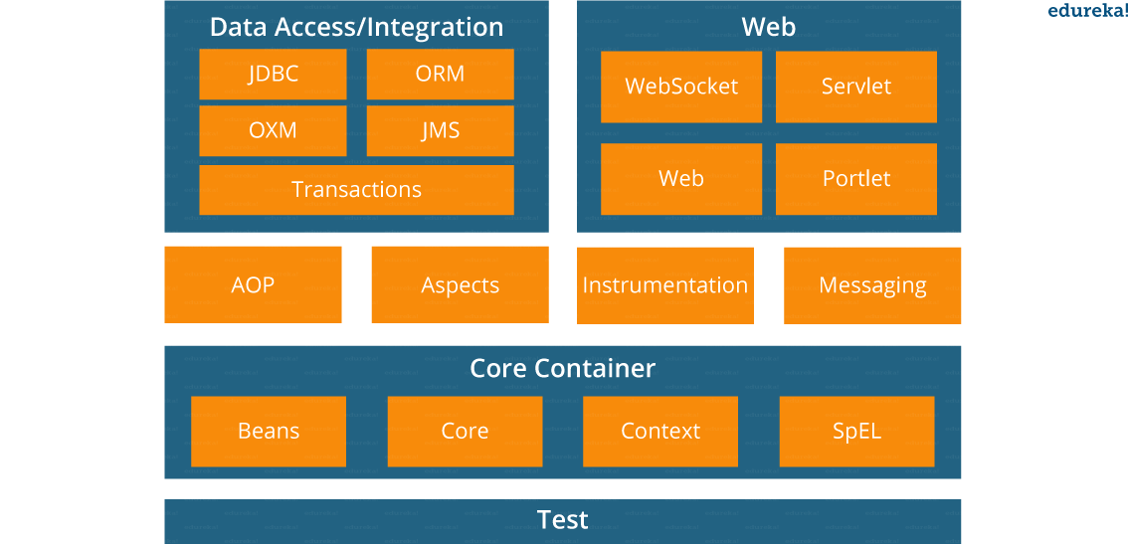
- Spring Core Container – This layer is basically the core of Spring Framework. It contains the following modules :
- Spring Core
- Spring Bean
- SpEL (Spring Expression Language)
- Spring Context
- Data Access/Integration – This layer provides support to interact with the database. It contains the following modules :
- JDBC (Java DataBase Connectivity)
- ORM (Object Relational Mapping)
- OXM (Object XML Mappers)
- JMS (Java Messaging Service)
- Transaction
- Web – This layer provides support to create web application. It contains the following modules :
- Web
- Web – MVC
- Web – Socket
- Web – Portlet
- Aspect Oriented Programming (AOP) – In this layer you can use Advices, Pointcuts etc., to decouplethe code.
- Instrumentation – This layer provides support to class instrumentation and classloader implementations.
- Test – This layer provides support to testing with JUnit and TestNG.
Few Miscellaneous modules are given below:
- Messaging – This module provides support for STOMP. It also supports an annotation programming model that is used for routing and processing STOMP messages from WebSocket clients.
- Aspects – This module provides support to integration with AspectJ.

6. What is a Spring configuration file?
A Spring configuration file is an XML file. This file mainly contains the classes information. It describes how those classes are configured as well as introduced to each other. The XML configuration files, however, are verbose and more clean. If it’s not planned and written correctly, it becomes very difficult to manage in big projects.

7. What are the different components of a Spring application?
A Spring application, generally consists of following components:
- Interface: It defines the functions.
- Bean class: It contains properties, its setter and getter methods, functions etc.
- Spring Aspect Oriented Programming (AOP): Provides the functionality of cross-cutting concerns.
- Bean Configuration File: Contains the information of classes and how to configure them.
- User program: It uses the function.

8. What are the various ways of using Spring Framework?
Spring Framework can be used in various ways. They are listed as follows:
- As a Full-fledged Spring web application.
- As a third-party web framework, using Spring Frameworks middle-tier.
- For remote usage.
- As Enterprise Java Bean which can wrap existing POJOs (Plain Old Java Objects).
The next section of Spring Interview Questions is on Dependency Injection and IoC container.

Dependency Injection/ IoC Container – Spring Interview Questions

9. What is Spring IOC Container?

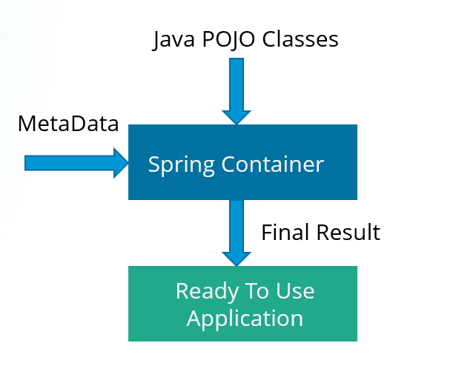
At the core of the Spring Framework, lies the Spring container. The container creates the object, wires them together, configures them and manages their complete life cycle. The Spring container makes use of Dependency Injection to manage the components that make up an application. The container receives instructions for which objects to instantiate, configure, and assemble by reading the configuration metadata provided. This metadata can be provided either by XML, Java annotations or Java code.

10. What do you mean by Dependency Injection?
In Dependency Injection, you do not have to create your objects but have to describe how they should be created. You don’t connect your components and services together in the code directly, but describe which services are needed by which components in the configuration file. The IoC container will wire them up together.

11. In how many ways can Dependency Injection be done?
In general, dependency injection can be done in three ways, namely :
- Constructor Injection
- Setter Injection
- Interface Injection
In Spring Framework, only constructor and setter injections are used.
Spring Framework Certification TrainingWatch The Course Preview

12. Differentiate between constructor injection and setter injection.

Constructor Injection vs Setter Injection
Constructor Injection | Setter Injection
There is no partial injection. | There can be partial injection.
It doesn’t override the setter property. | It overrides the constructor property.
It will create a new instance if any modification is done. | It will not create new instance if any modification is done.
It works better for many properties. | It works better for few properties.

13. How many types of IOC containers are there in spring?
- BeanFactory: BeanFactory is like a factory class that contains a collection of beans. It instantiates the bean whenever asked for by clients.
- ApplicationContext: The ApplicationContext interface is built on top of the BeanFactory interface. It provides some extra functionality on top BeanFactory.
BeanFactory | ApplicationContext
It is an interface defined in org.springframework.beans.factory.BeanFactory | It is an interface defined in org.springframework.context.ApplicationContext
It uses Lazy initialization | It uses Eager/ Aggressive initialization
It explicitly provides a resource object using the syntax | It creates and manages resource objects on its own
It doesn’t supports internationalization | It supports internationalization
It doesn’t supports annotation based dependency | It supports annotation based dependency

14. Differentiate between BeanFactory and ApplicationContext.

BeanFactory vs ApplicationContext

15. List some of the benefits of IoC.
Some of the benefits of IoC are:
- It will minimize the amount of code in your application.
- It will make your application easy to test because it doesn’t require any singletons or JNDI lookup mechanisms in your unit test cases.
- It promotes loose coupling with minimal effort and least intrusive mechanism.
- It supports eager instantiation and lazy loading of the services.
Let’s move on to the next section of Spring Interview Questions, that is Spring Beans Interview Questions.

Spring Beans – Spring Interview Questions

16. Explain Spring Beans?
- They are the objects that form the backbone of the user’s application.
- Beans are managed by the Spring IoC container.
- They are instantiated, configured, wired and managed by a Spring IoC container
- Beans are created with the configuration metadata that the users supply to the container.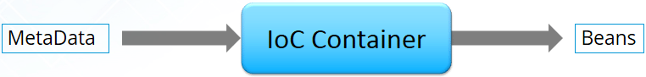

17. How configuration metadata is provided to the Spring container?
Configuration metadata can be provided to Spring container in following ways:
- XML-Based configuration: In Spring Framework, the dependencies and the services needed by beans are specified in configuration files which are in XML format. These configuration files usually contain a lot of bean definitions and application specific configuration options. They generally start with a bean tag. For example:
1  2  3 | <bean id="studentbean" class="org.edureka.firstSpring.StudentBean">  <property name="name" value="Edureka"></property>  </bean>
- Annotation-Based configuration: Instead of using XML to describe a bean wiring, you can configure the bean into the component class itself by using annotations on the relevant class, method, or field declaration. By default, annotation wiring is not turned on in the Spring container. So, you need to enable it in your Spring configuration file before using it. For example:
1  2  3  4 | <beans>  <context:annotation-config/>  <!-- bean definitions go here -->  </beans>
- Java-based configuration: The key features in Spring Framework’s new Java-configuration support are @Configuration annotated classes and @Bean annotated methods.
1. @Bean annotation plays the same role as the <bean/> element.
2.@Configuration classes allows to define inter-bean dependencies by simply calling other @Bean methods in the same class.
For example:
1  2  3  4  5  6  7 | @Configuration  public class StudentConfig  {  @Bean  public StudentBean myStudent()  { return new StudentBean(); }  }

18. How many bean scopes are supported by Spring?
The Spring Framework supports five scopes. They are:
- Singleton: This provides scope for the bean definition to single instance per Spring IoC container.
- Prototype: This provides scope for a single bean definition to have any number of object instances.
- Request: This provides scope for a bean definition to an HTTP-request.
- Session: This provides scope for a bean definition to an HTTP-session.
- Global-session: This provides scope for a bean definition to an Global HTTP-session.
The last three are available only if the users use a web-aware ApplicationContext.

19. What is the Bean life cycle in Spring Bean Factory Container?
Bean life cycle in Spring Bean Factory Container is as follows:
- The Spring container instantiates the bean from the bean’s definition in the XML file.
- Spring populates all of the properties using the dependency injection, as specified in the bean definition.
- The factory calls setBeanName() by passing the bean’s ID, if the bean implements the BeanNameAware interface.
- The factory calls setBeanFactory() by passing an instance of itself, if the bean implements the BeanFactoryAware interface.
- preProcessBeforeInitialization() methods are called if there are any BeanPostProcessors associated with the bean.
- If an init-method is specified for the bean, then it will be called.
- Finally, postProcessAfterInitialization() methods will be called if there are any BeanPostProcessors associated with the bean.
To understand it in better way check the below diagram:
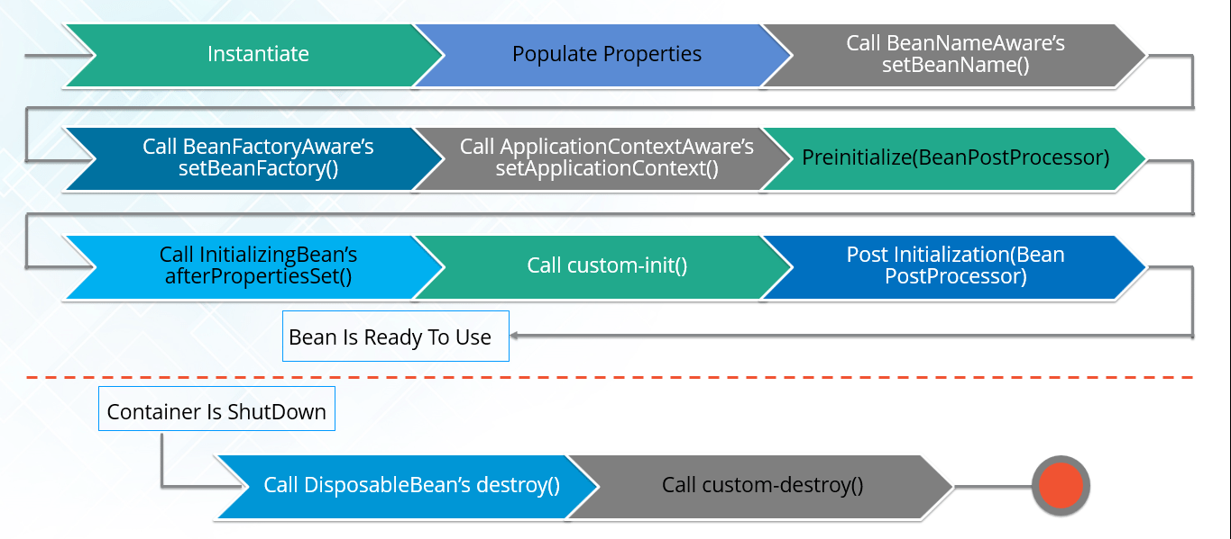

20. Explain inner beans in Spring.
A bean can be declared as an inner bean only when it is used as a property of another bean. For defining a bean, the Spring’s XML based configuration metadata provides the use of <bean> element inside the <property> or <constructor-arg>. Inner beans are always anonymous and they are always scoped as prototypes. For example, let’s say we have one Student class having reference of Person class. Here we will be creating only one instance of Person class and use it inside Student.
Here’s a Student class followed by bean configuration file:
Student.java
1  2  3  4  5  6  7  8  9  10  11 | public class Student  {  private Person person;  //Setters and Getters  }  public class Person  {  private String name;  private String address;  //Setters and Getters  }
studentbean.xml
1  2  3  4  5  6  7  8  9 | <bean id=“StudentBean" class="com.edureka.Student">  <property name="person">  <!--This is inner bean -->  <bean class="com.edureka.Person">  <property name="name" value=“Scott"></property>  <property name="address" value=“Bangalore"></property>  </bean>  </property>  </bean>

21. Define Bean Wiring.
When beans are combined together within the Spring container, it’s called wiring or bean wiring. The Spring container needs to know what beans are needed and how the container should use dependency injection to tie the beans together, while wiring beans.
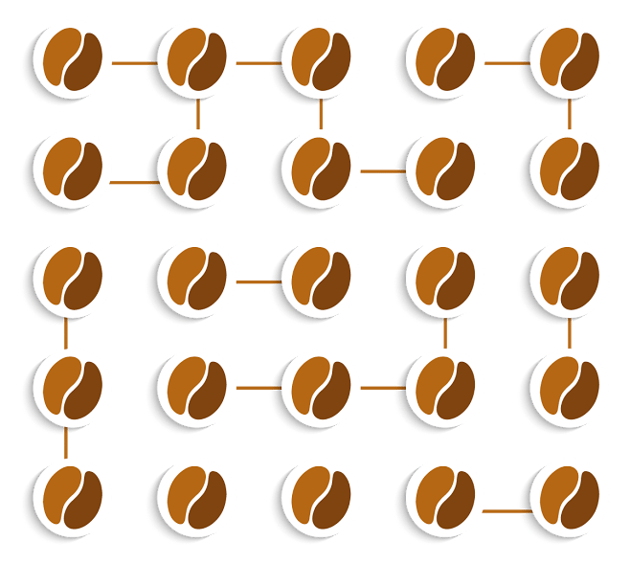

Q32. What is Spring Security?
Spring Security is a powerful and highly customizable authentication and access-control framework. It is the de facto standard for securing Spring-based applications. Spring Security is a framework that focuses on providing both authentication and authorization to Java applications. Here is the list of some of the most common features of Spring security.
- Support for Authentication and Authorization.
- Out of the box support for CSRF, session fixation, etc.
- OOTB integration with Spring MVC.
- Support to integrate external authentication systems.
Explain the difference between concern and crosscutting concern in Spring AOP?
The concern can be defined as a functionality/feature a programmer wants to implement to address a specific business problem. For example, In eCommerce applications a concern can be stock management, shipping management etc.
Crosscutting concern is a concern than span across almost all modules of an application. For example, logging, security etc.

******* Questions Discussed in this Interview Course *******
Spring
- What is Loose Coupling?
- What is a Dependency?
- What is IOC (Inversion of Control)?
- What is Dependency Injection?
- Can you give few examples of Dependency Injection?
- What is Auto Wiring?
- What are the important roles of an IOC Container?
- What are Bean Factory and Application Context?
- Can you compare Bean Factory with Application Context?
- How do you create an application context with Spring?
- How does Spring know where to search for Components or Beans?
- What is a Component Scan?
- How do you define a component scan in XML and Java Configurations?
- How is it done with Spring Boot?
- What does @Component signify?
- What does @Autowired signify?
- What’s the difference Between @Controller, @Component, @Repository, and @Service Annotations in Spring?
- What is the default scope of a bean?
- Are Spring beans thread safe?
- What are the other scopes available?
- How is Spring’s singleton bean different from Gang of Four Singleton Pattern?
- What are the different types of dependency injections?
- What is setter injection?
- What is constructor injection?
- How do you choose between setter and constructor injections?
- What are the different options available to create Application Contexts for Spring?
- What is the difference between XML and Java Configurations for Spring?
- How do you choose between XML and Java Configurations for Spring?
- How does Spring do Autowiring?
- What are the different kinds of matching used by Spring for Autowiring?
- How do you debug problems with Spring Framework?
- How do you solve NoUniqueBeanDefinitionException?
- How do you solve NoSuchBeanDefinitionException?
- What is @Primary?
- What is @Qualifier?
- What is CDI (Contexts and Dependency Injection)?
- Does Spring Support CDI?
- Would you recommed to use CDI or Spring Annotations?
- What are the major features in different versions of Spring?
- What are new features in Spring Framework 4.0?
- What are new features in Spring Framework 5.0?
- What are important Spring Modules?
- What are important Spring Projects?
- What is the simplest way of ensuring that we are using single version of all Spring related dependencies?
- Name some of the design patterns used in Spring Framework?
- What do you think about Spring Framework?
- Why is Spring Popular?
- Can you give a big picture of the Spring Framework?
Spring MVC
- What is Model 1 architecture?
- What is Model 2 architecture?
- What is Model 2 Front Controller architecture?
- Can you show an example controller method in Spring MVC?
- Can you explain a simple flow in Spring MVC?
- What is a ViewResolver?
- What is Model?
- What is ModelAndView?
- What is a RequestMapping?
- What is Dispatcher Servlet?
- How do you set up Dispatcher Servlet?
- What is a form backing object?
- How is validation done using Spring MVC?
- What is BindingResult?
- How do you map validation results to your view?
- What are Spring Form Tags?
- What is a Path Variable?
- What is a Model Attribute?
- What is a Session Attribute?
- What is a init binder?
- How do you set default date format with Spring?
- Why is Spring MVC so popular?
Spring Boot
- What is Spring Boot?
- What are the important Goals of Spring Boot?
- What are the important Features of Spring Boot?
- Compare Spring Boot vs Spring?
- Compare Spring Boot vs Spring MVC?
- What is the importance of @SpringBootApplication?
- What is Auto Configuration?
- How can we find more information about Auto Configuration?
- What is an embedded server? Why is it important?
- What is the default embedded server with Spring Boot?
- What are the other embedded servers supported by Spring Boot?
- What are Starter Projects?
- Can you give examples of important starter projects?
- What is Starter Parent?
- What are the different things that are defined in Starter Parent?
- How does Spring Boot enforce common dependency management for all its Starter projects?
- What is Spring Initializr?
- What is application.properties?
- What are some of the important things that can customized in application.properties?
- How do you externalize configuration using Spring Boot?
- How can you add custom application properties using Spring Boot?
- What is @ConfigurationProperties?
- What is a profile?
- How do you define beans for a specific profile?
- How do you create application configuration for a specific profile?
- How do you have different configuration for different environments?
- What is Spring Boot Actuator?
- How do you monitor web services using Spring Boot Actuator?
- How do you find more information about your application envrionment using Spring Boot?
- What is a CommandLineRunner?
Database Connectivity - JDBC, Spring JDBC & JPA
- What is Spring JDBC? How is different from JDBC?
- What is a JdbcTemplate?
- What is a RowMapper?
- What is JPA?
- What is Hibernate?
- How do you define an entity in JPA?
- What is an Entity Manager?
- What is a Persistence Context?
- How do you map relationships in JPA?
- What are the different types of relationships in JPA?
- How do you define One to One Mapping in JPA?
- How do you define One to Many Mapping in JPA?
- How do you define Many to Many Mapping in JPA?
- How do you define a datasource in a Spring Context?
- What is the use of persistence.xml
- How do you configure Entity Manager Factory and Transaction Manager?
- How do you define transaction management for Spring – Hibernate integration?
Spring Data
- What is Spring Data?
- What is the need for Spring Data?
- What is Spring Data JPA?
- What is a CrudRepository?
- What is a PagingAndSortingRepository?
Unit Testing
- How does Spring Framework Make Unit Testing Easy?
- What is Mockito?
- What is your favorite mocking framework?
- How do you do mock data with Mockito?
- What are the different mocking annotations that you worked with?
- What is MockMvc?
- What is @WebMvcTest?
- What is @MockBean?
- How do you write a unit test with MockMVC?
- What is JSONAssert?
- How do you write an integration test with Spring Boot?
- What is @SpringBootTest?
- What is @LocalServerPort?
- What is TestRestTemplate?
AOP
- What are cross cutting concerns?
- How do you implement cross cutting concerns in a web application?
- If you would want to log every request to a web application, what are the options you can think of?
- If you would want to track performance of every request, what options can you think of?
- What is an Aspect and Pointcut in AOP?
- What are the different types of AOP advices?
- What is weaving?
- Compare Spring AOP vs AspectJ?
SOAP Web Services
- What is a Web Service?
- What is SOAP Web Service?
- What is SOAP?
- Waht is a SOAP Envelope?
- What is SOAP Header and SOAP Body?
- Can you give an example of SOAP Request and SOAP Response?
- What is a SOAP Header? What kind of information is sent in a SOAP Header?
- Can you give an example of a SOAP Header with Authentication information?
- What is WSDL (Web Service Definition Language)?
- What are the different parts of a WSDL?
- What is Contract First Approach?
- What is an XSD?
- Can you give an example of an XSD?
- What is JAXB?
- How do you configure a JAXB Plugin?
- What is an Endpoint?
- Can you show an example endpoint written with Spring Web Services?
- What is a MessageDispatcherServlet?
- How do you configure a MessageDispatcherServlet?
- How do you generate a WSDL using Spring Web Services?
- How do you implement error handling for SOAP Web Services?
- What is a SOAP Fault?
RESTful Web Services
- What is REST?
- What are the key concepts in designing RESTful API?
- What are the Best Practices of RESTful Services?
- Can you show the code for an example Get Resource method with Spring REST?
- What happens when we return a bean from a Request Mapping Method?
- What is GetMapping and what are the related methods available in Spring MVC?
- Can you show the code for an example Post Resource method with Spring REST?
- What is the appropriate HTTP Response Status for successful execution of a Resource Creation?
- Why do we use ResponseEntity in a RESTful Service?
- What is HATEOAS?
- Can you give an Example Response for HATEOAS?
- How do we implement it using Spring?
- How do you document RESTful web services?
- Can you give a brief idea about Swagger Documentation?
- How do you automate generation of Swagger Documentation from RESTful Web Services?
- How do you add custom information to Swagger Documentation generated from RESTful Web Services?
- What is Swagger-UI?
- What is "Representation" of a Resource?
- What is Content Negotiation?
- Which HTTP Header is used for Content Negotiation?
- How do we implement it using Spring Boot?
- How do you add XML support to your RESTful Services built with Spring Boot?
- How do you implement Exception Handling for RESTFul Web Services?
- What are the best practices related to Exception Handling with respect to RESTful Web Services?
- What are the different error status that you would return in RESTful Web Services?
- How would you implement them using Spring Boot?
- What HTTP Response Status do you return for validation errors?
- How do you handle Validation Errors with RESTful Web Services?
- Why do we need Versioning for RESTful Web Services?
- What are the versioning options that are available?
- How do you implement Versioning for RESTful Web Services?

